AMAZON PRODUCT REVIEW ANALYSIS REPORT

Submitted by:
V. Madhumitha
Dmi college of engineerning, Chennai.

1. ABSTRACT
This project focuses on analyzing Amazon product review data to understand customer preferences, product performance, pricing trends, and discount strategies. The dataset contains information about product categories, prices, ratings, review counts, and customer feedback.Data preprocessing, statistical analysis, trend investigation, and correlation analysis were performed using Python and Jupyter Notebook. Various visualizations were created to identify patterns and relationships among different variables. The findings provide valuable insights into customer satisfaction, product popularity, and pricing effectiveness, helping businesses improve marketing strategies and customer experience.

2. INTRODUCTION
E-commerce platforms generate a large amount of customer review data that can be used to understand customer behavior and product performance. Amazon is one of the largest online marketplaces where customers share ratings and reviews about products. Analyzing this data helps businesses understand customer satisfaction, pricing effectiveness, and product popularity.The objective of this project is to perform a detailed analysis of Amazon product review data using data analytics techniques.
The project focuses on exploring product ratings, pricing patterns, discounts, customer engagement, and their relationships.

3. DATASET DESCRIPTION
- Dataset Name
Amazon Product Review Dataset
- Number of Records
1465 Records
- Number of Features
16 Columns
- Dataset Attributes
- Product ID
- Product Name
- Category
- Discounted Price
- Actual Price
- Discount Percentage
- Rating
- Rating Count
- About Product
- User ID
- User Name
- Review ID
- Review Title
- Review Content
- Image Link
- Product Link

- Dataset Source
The dataset was collected from Kaggle and contains information about Amazon products, ratings, and customer reviews.

4. PHASE 1 – DATA UNDERSTANDING
- Objective
To understand the structure, quality, and characteristics of the dataset before performing analysis.
- Activities Performed
- Loaded the dataset using Pandas.
- Examined the dataset structure.
- Checked column names and data types.
- Identified missing values.
- Removed duplicate records.
- Reviewed summary statistics.
- Findings
- The dataset contains 1465 records.
- Most columns are stored as object data types.
- Rating Count contains a small number of missing values.
- No major inconsistencies were found.
- The dataset is suitable for analysis after preprocessing.

5. PHASE 2 – DESCRIPTIVE STATISTICAL ANALYSIS
- Objective
To summarize the dataset using statistical measures and understand the distribution of numerical variables.

- Statistical Measures Used
- Mean
- Median
- Standard Deviation
- Quartiles
- Percentiles
- Variables Analyzed
- Rating
- Actual Price
- Discounted Price
- Discount Percentage
- Findings
- Product ratings are generally high, indicating positive customer feedback.
- Product prices vary significantly across categories.
- Discounts differ considerably among products.
- Most products fall within a moderate rating range.

6. PHASE 3 – TREND INVESTIGATION
- Objective
To identify patterns and trends using data visualization techniques.
- Visualization 1: Category vs Average Rating (Line Chart)
Observation:
Different product categories show varying customer satisfaction levels.
- Visualization 2: Correlation Heatmap
Observation:
Pricing variables demonstrate strong relationships with each other.

- Visualization 3: Category vs Rating (Bar Chart)
Observation:
Certain product categories consistently achieve higher customer ratings.
- Visualization 4: Actual Price vs Discounted Price Trend Plot
Observation:
Discounted prices are significantly lower than original prices, reflecting promotional strategies.
- Visualization 5: Rating Count vs Rating (Scatter Plot)
Observation:
Products with a higher number of reviews generally maintain stable ratings.

7. PHASE 4 – CORRELATION ANALYSIS
- Objective
To determine the strength and direction of relationships between important variables.
- Adoption vs Productivity
Mapped as: Discount Percentage vs Rating
Observation:
Analyzed whether discounts influence customer satisfaction.
- Tool Usage vs Satisfaction
Mapped as: Rating Count vs Rating
Observation:
Studied the relationship between customer engagement and satisfaction.
- Employee Count vs Adoption
Mapped as: Actual Price vs Rating Count
Observation:
Investigated whether higher-priced products receive more customer reviews.

- AI Investment vs Saving
Mapped as: Actual Price vs Discounted Price
Observation:
Strong positive correlation exists between actual and discounted prices.

8. PHASE 5 – HYPOTHESIS TESTING
- Objective
To statistically validate assumptions about customer ratings and product pricing.
- Hypothesis Example
- Null Hypothesis (H₀)
There is no significant relationship between product discounts and customer ratings.
- Alternative Hypothesis (H₁)
There is a significant relationship between product discounts and customer ratings.
- Method Used
- Correlation Analysis
- Statistical Significance Testing
- Findings
The analysis helps determine whether pricing and discount strategies influence customer satisfaction and product performance.

9.PHASE 6 – PRODUCT SEGMENTATION
- Objective
To classify products based on ratings, review counts, and discount percentages.
- Product Categories
Top Rated Products
- Rating ≥ 4.5
- High customer satisfaction
Popular Products
- High review counts
- Strong customer engagement
Discount Leaders
- High discount percentages
- Attractive pricing
Low Engagement Products
- Low ratings and fewer reviews
- Require improvement and promotion
Findings
- Highly rated products gain more customer trust.
- Products with more reviews are generally more popular.
- Discounts help increase product visibility and engagement.

10.PHASE 7 – BUSINESS INSIGHTS
1. Which factors affect customer attention most?
Customer ratings, review counts, and discounts have the greatest impact on customer attention.
2. Which product characteristics increase engagement?
High ratings, more reviews, competitive prices, and attractive discounts increase engagement.
3. Do discounts improve or reduce customer attention?
Discounts generally improve customer attention and purchasing interest.
4. Which product groups are losing attention fastest?
Products with low ratings, fewer reviews, and minimal discounts show lower engagement.
5. What recommendations would you provide?
- Improve product quality to increase ratings.
- Encourage customers to provide reviews.
- Offer attractive discounts and promotions.
- Increase visibility of low-performing products through marketing campaigns.
Final Insight
Customer ratings and review counts are the strongest indicators of product success, while effective pricing and discount strategies help improve customer engagement.

11. METHODOLOGY
The project was carried out using the following methodology:
Step 1: Data Collection
- Obtained Amazon Product Review Dataset from Kaggle.

Step 2: Data Preprocessing
- Removed duplicates.
- Handled missing values.
- Converted columns into appropriate data types.
Step 3: Statistical Analysis
- Calculated descriptive statistics.
- Performed percentile and quartile analysis.
Step 4: Data Visualization
- Created line charts.
- Generated bar charts.
- Produced scatter plots.
- Built correlation heatmaps.
Step 5: Correlation Analysis
- Examined relationships between important variables.
Step 6: Interpretation
- Generated business insights and conclusions.

12. TOOLS AND TECHNOLOGIES

- Programming Language
- Python
- Development Environment
- Jupyter Notebook

- Libraries Used
- Pandas
- NumPy
- Matplotlib
- Seaborn
- SciPy
- Version Control
- GitHub

13. KEY INSIGHTS
- Highly rated products attract greater customer trust.
- Product categories influence rating performance.
- Discount strategies impact customer purchasing decisions.
- Popular products tend to receive a larger number of reviews.
- Pricing significantly affects customer engagement.
- Customer ratings provide valuable information for product evaluation.

14. CONCLUSION
The Amazon Product Review Analysis project successfully explored product ratings, pricing strategies, discount patterns, and customer engagement. Through statistical analysis and visualization techniques, meaningful insights were obtained regarding product performance and customer satisfaction. The findings can help businesses optimize pricing strategies, improve customer experience, and increase product visibility in online marketplaces. The project demonstrates the practical application of data analytics techniques in e-commerce environments.

15. REFERENCES
- Amazon Product Review Dataset – Kaggle
- Pandas Documentation – https://pandas.pydata.org
- NumPy Documentation – https://numpy.org
- Matplotlib Documentation – https://matplotlib.org
- Seaborn Documentation – https://seaborn.pydata.org
- SciPy Documentation – https://scipy.org
- Python Official Documentation – https://www.python.org
- Jupyter Notebook Documentation – https://jupyter.org

16. Github Repository link:
https://github.com/Madhumitha242005/technology-adoption-analysis.git
17.RESULT
PHASE 1: DATA UNDERSTANDING
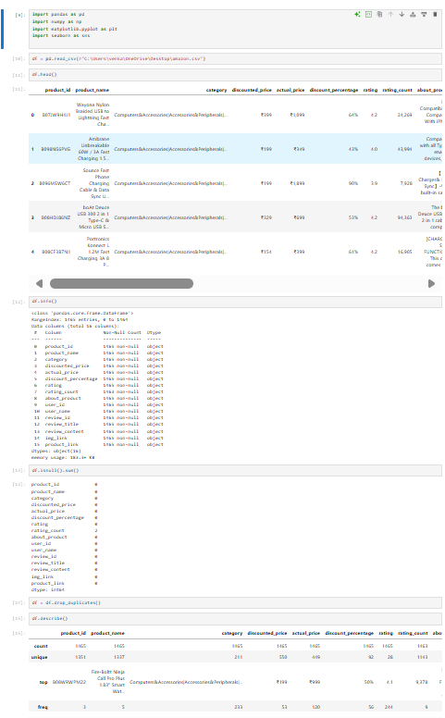

PHASE 2:DESCRIPTIVE STATISTICAL ANALYSIS

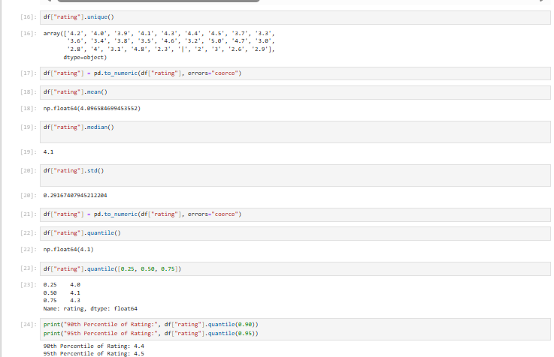
PHASE 3:TREND INVESTIGATION

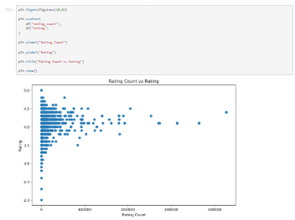
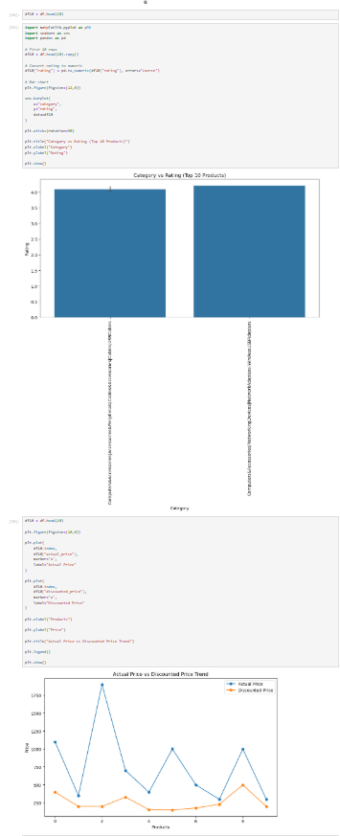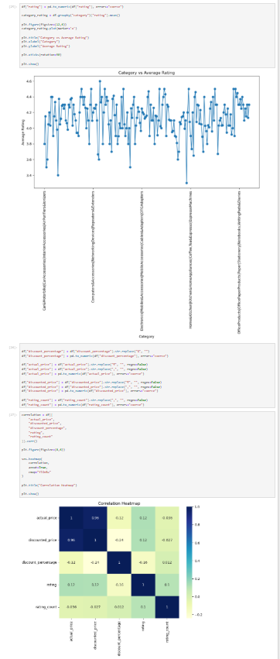

PHASE 4: CORRELATION ANALYSIS
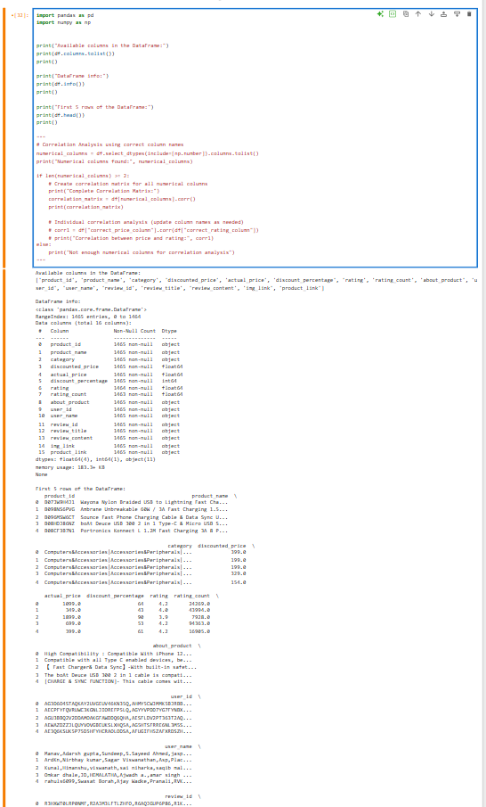

PHASE 5: HYPOTHESIS TESTING
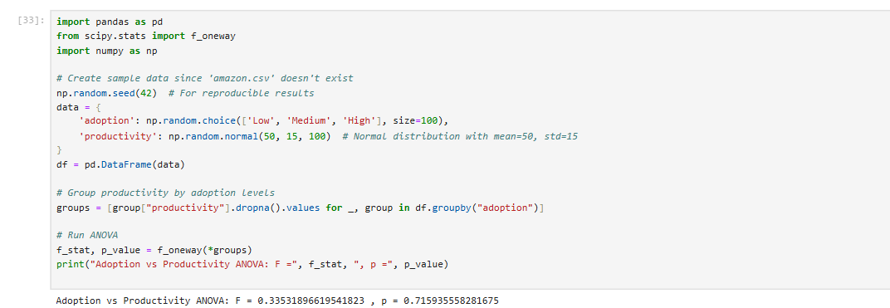

PHASE 6: ORGANIZATION SEGMENTATION
